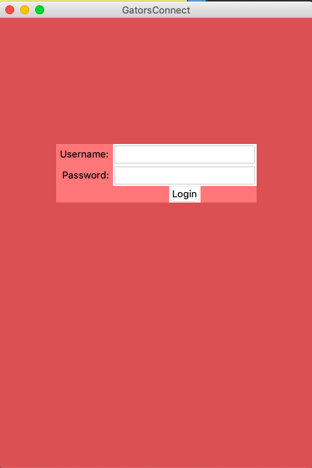

1. GatorsConnect Log in Window: Insert user credentials in the Username and Password inputs.
   1. Admin Login:
      1. Username: Chang
      2. Password: password
   2. Student Login:
      1. Username: s1 or s2 or s3 … s40
      2. Password: p1 or p2 or p3 … p40

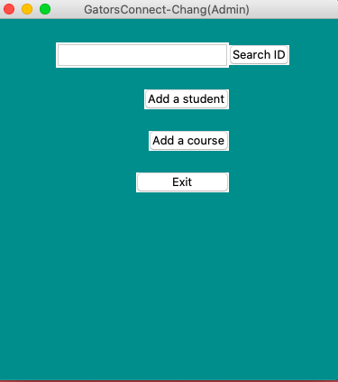

1. GatorsConnect Admin Window: Once logged into Admin account, use the input above to search student’s ID.
   1. Student names: s1,s2,s3,s4

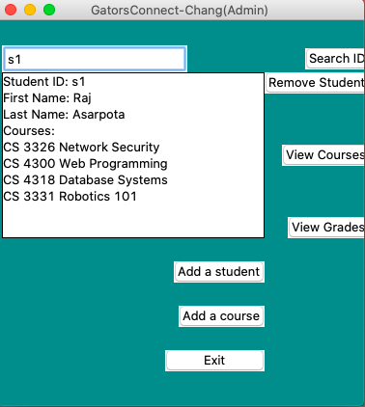

GatorsConnect Student Search Window: The student’s first name, last name, and list of courses are presented once the Admin searches the student ID.

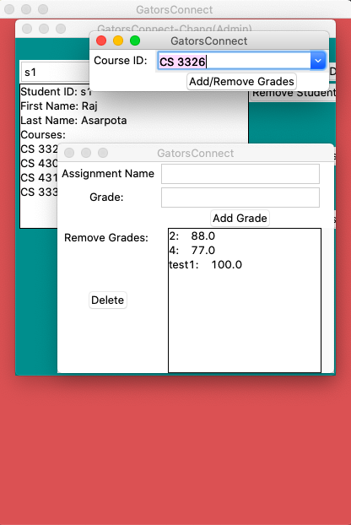

GatorsConnect View/Add/Remove Grades Window: Once the view grades button has been selected, the Admin is now able to select the course for that student, then proceed to view/add/remove grades for the selected course.

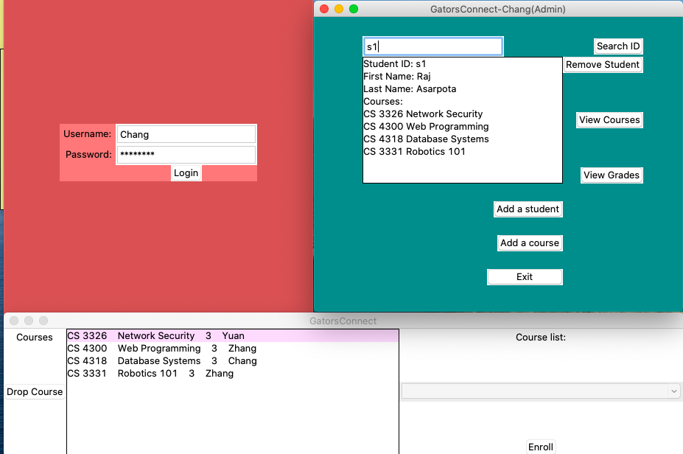

GatorsConnect View Course Window: Once the view a course button has been selected, the Admin can view the course list details that student has enrolled for, then enroll/drop a selected course for the student.

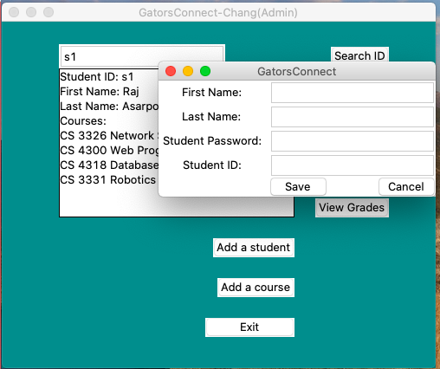

GatorsConnect Add Student Window: Once the Add a student button has been selected, the Admin can insert the First name, Last name, Student password, and Student ID and save a new student to the database. A selected student can be removed by selecting the Remove student button.

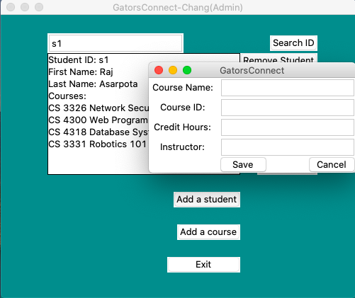

GatorsConnect Add Course Window: Once the add a course button has been selected, the Admin can insert course name, course ID, credit hours, and instructor and save a new course for the selected student. The exit button can be selected at any time to return to the GatorsConnect Login Window.

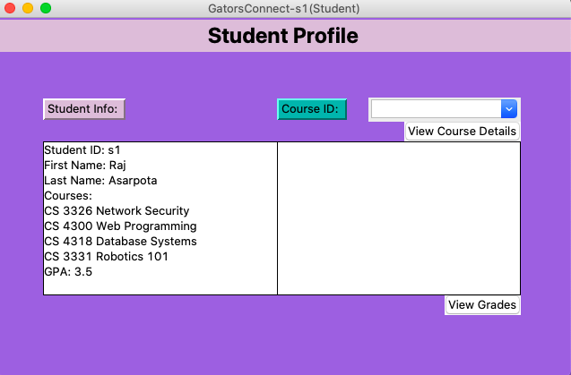

GatorsConnect Student Profile Window: Once logged in as a student, the student’s information has been presented (student ID, first name, last name courses, and GPA)

1. Student Login:
   * 1. Username: s1 or s2 or s3… s40
     2. Password: p1 or p2 or p3…. p40

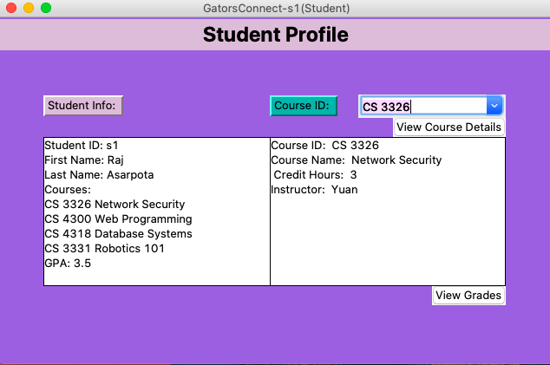

GatorsConnect View Course Details Window: Once the view course details button has been selected, the student can now view the course details of a selected course that student is enrolled in.

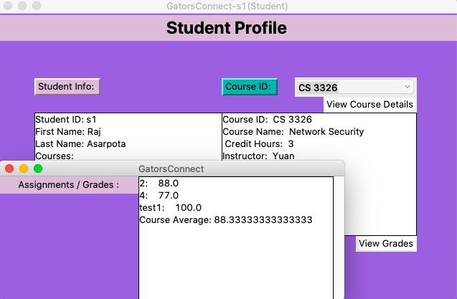

GatorsConnect View Grades Window: Once the view grades button has been selected, the student can now view the assignments, grades, and course average for the selected course.